Learn to dive into a whole new world with ***Big Kahuna Scuba***!!

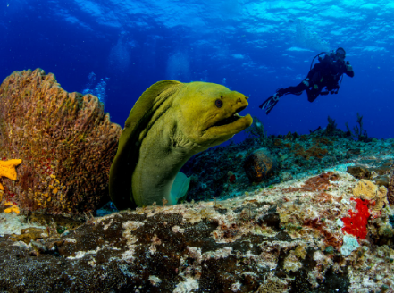

We offer a personalized learning experience that focuses on Safety and You. Our class sizes are small because we only offer private and semiprivate small group classes.   
  
We are truly an All-Inclusive program. Many say they are all inclusive, but don’t really include everything you need to learn how to Scuba. We do, everything is included!  
  
We train with the latest techniques that focus on fun, safety and build you confidence one skill at a time. We don’t move on until you have mastery of the skill. Our training is built around your needs, not some canned, off the shelf, push you along program. At NAUI, we have academic freedom to tailor the course around you and your needs to meet the requirements for certification.   
  
**We are proud to offer the following programs from NAUI.** (**N**ational **A**ssociation of **U**nderwater **I**nstructors). See [www.naui.org](http://www.naui.org)

**Try Scuba**: Only $175.00 AND if you sign up for Open Water, we’ll credit $50 to your Open Water course! Winter Rates: $250.00.   
  
**Refresher**: Have you been out of the water for 5 years or less? Let’s brush up on your skills, safety and get you back in the water with confidence! 2-hour class: $175.00. Winter rates $250.00  
  
**Open Water**: This is the class to get you certified as a Scuba Diver! Certify in 3 Easy Steps: E-learning Academics, Pool Classes & Open Water Certification Dives. $925.00. With Winter Season Pool Rental: $1150.00.

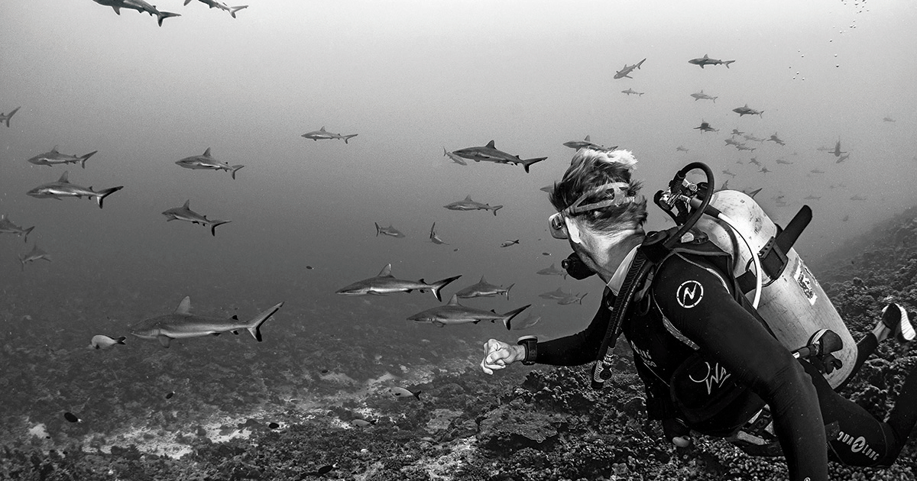In addition, we offer a variety of continuing education classes to further your scuba diving journey!

***In just 3 easy steps you can become a certified NAUI diver!***

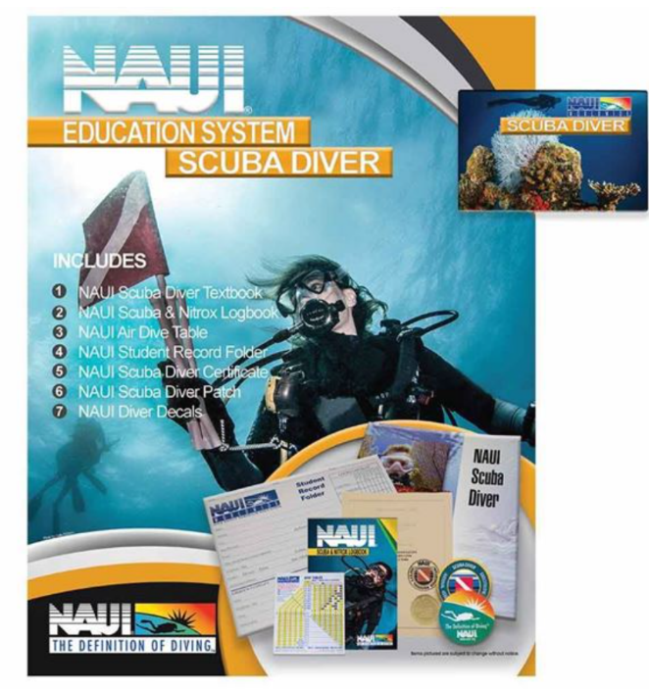**Step 1:  Academics**

Step #1: During this step, you will learn everything you need to know with NAUI’s award winning E-learning program. Equipment, Skills, Dive Science, Dive Planning, Dive Environment & Problem Solving. The best part? **It's all done at home and at your own pace.**

**Step 2. The Pool.**

***  
  
  
**Step 2:  Academic Review and Pool Sessions**After completion of your home study, you will get your fins wet in our comfortable home pool setting! You will learn to use SCUBA equipment and practice the skills required for safe diving while experiencing the fun and excitement of the underwater world. Typically, 3 3-hour pool sessions or longer weekend sessions

**Step 3:  Certification Dive Trip: Blue Water Park in Pelham AL**

Use the skills you practiced in the pool to complete your certification on 4 fun and safe dives in the Blue Water Park Quarry in Pelham Alabama (over two days/stay over one night) and earn your lifetime certification as an "NAUI Open Water Diver” Typical Schedule: 3 dives Saturday, 1 dive Sunday and back to Atlanta by mid-afternoon! [www.bluewaterparkal.com](http://www.bluewaterparkal.com)  
  
  
**What is Included in the All-Inclusive Price:**• NAUI’s Award Winning E-Learning Program   
• Academic Review Sessions  
• Pool/Confined Water training sessions at our home pool.  
•Equipment: BCD, Regulator, Gauges, Computer, Wetsuit, Weights, and Tanks. In addition, we include mask, fins, and snorkel. Most programs do not. A savings of $125 to $300.  
• All Air Fills  
• Park Entry fees for certification dives at Blue Water Park in Pelham Alabama  
• Saturday lunch at Blue Water Park  
• Certification Card

***\*\*\*\*Steps 2 and 3 can be completed in 1 week!!***

**What is Not Included in the Price:**--Transportation to and from Blue Water Park in Pelham AL

--Lodging Saturday night in Pelham AL. There are a wide variety of hotels in the area.  
--Meals   
  
**Guidelines for classes: Sometimes, students cannot finish the course. We understand that.**--After the first confined water/pool class if this isn’t for you, we offer a 50% refund. This covers our upfront costs: E-learning etc.  
  
--After all confined water/pool classes, the refund is 25%  
  
--Can’t complete the first open water dive: can’t clear your ears, can’t overcome claustrophobia etc. there is no refund.